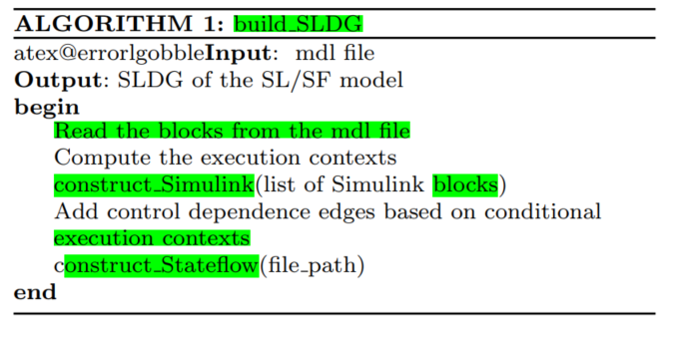

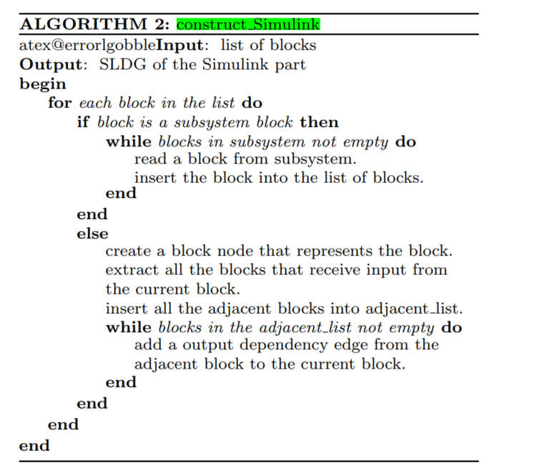

**ALGORITHM 1**: Parse Simulink model data

**Input**: source path of slx or mdl model files  
**Output**: json data files

**begin**

Prepare the list from all the slx or mdl files

**for** each file in the list **do**

create a model node that represents the model

read the blocks from the model

**for** each block in the list **do**

create a block node that represents the block

create a block-model relationship that represents the block with model

**end**

read the ports from the model

**for** each port in the list **do**

create a port node that represents the port

create a port-block relationship that represents the port with block

**end**

read the lines from the model

**for** each line in the list **do**

create a port-port relationship that represents the model signal

**end**

create the json data file for each model

**end**

**Latex Code:** [**https://latex.org/forum/viewtopic.php?t=16066**](https://latex.org/forum/viewtopic.php?t=16066)

**V1.2:**

**\documentclass[11pt]{article}**

**\usepackage[T1]{fontenc}**

**\usepackage{algorithm,algorithmic}**

**\newcommand{\STATEnonum}{\item[]}**

**\begin{document}**

**\begin{algorithm}**

**\caption{Parse Simulink Model Data}\label{alg:calcqij}**

**\begin{algorithmic}[1]**

**\STATEnonum \textbf{INPUT:} {source directory of all slx or mdl model files}**

**\STATEnonum \textbf{OUTPUT:}{json data file for each model}**

**\STATE {prepare the list for all slx or mdl model files}**

**\FOR{each model file in the list}**

**\STATE {create a node that represents the model}**

**\STATE {prepare the list for all blocks in the model}**

**\FOR{each block in the list}**

**\STATE {create a node that represents the block}**

**\STATE {create a relationship that connects the block with the model}**

**\ENDFOR**

**\STATE {prepare the list for all ports in the model}**

**\FOR {each port in the list}**

**\STATE {create a node that represents the port}**

**\STATE {create a relationship that connects the port with the corresponding block}**

**\ENDFOR**

**\STATE {prepare the list for all lines/signals in the model}**

**\FOR {each line in the list }**

**\STATE {create a relationship that connects the line with two corresponding port nodes}**

**\ENDFOR**

**\STATE {create a json file for each model}**

**\ENDFOR**

**\end{algorithmic}**

**\end{algorithm}**

**\end{document}**

**V1.1:**

**\documentclass[11pt]{article}**

**\usepackage[T1]{fontenc}**

**\usepackage{algorithm,algorithmic}**

**\newcommand{\STATEnonum}{\item[]}**

**\begin{document}**

**\begin{algorithm}**

**\caption{Parse Simulink model data}\label{alg:calcqij}**

**\begin{algorithmic}[1]**

**\STATEnonum \textbf{INPUT:} {source path of slx or mdl model files}**

**\STATEnonum \textbf{OUTPUT:}{json data files}**

**\STATE {Prepare the list for all the slx or mdl files}**

**\FOR{each file in the list}**

**\STATE {create a model node that represents the model}**

**\STATE {read the blocks from the model }**

**\FOR{each block in the list}**

**\STATE {create a block node that represents the block}**

**\STATE {create a block-model relationship that represents the block with model}**

**\ENDFOR**

**\STATE {read the ports from the model}**

**\FOR {each port in the list}**

**\STATE {create a port node that represents the port}**

**\STATE {create a port-block relationship that represents the port with block}**

**\ENDFOR**

**\STATE {read the lines from the model}**

**\FOR {each line in the list }**

**\STATE {create a port-to-port node relationship that represents the model line/signal}**

**\ENDFOR**

**\STATE {create a json data file for each model}**

**\ENDFOR**

**\end{algorithmic}**

**\end{algorithm}**

**\end{document}**